Template for LAMP-2009 Abstract
(18 Point, Centred and Bold, Times New Roman)

A. Author¹, B. Author², C. Author³
(list of authors in 10 point, centred and bold: the presenting author underlined)
1- The author affiliation and full address should be located here in 8 point, centred and in italics
2- Address of author² if different
3- Address of author³ if different

Main author email address: in 10 point, centred and in italics

The abstract must be written in English. There will be no formatting done to the abstract prior to publication in the abstract book. Therefore it is very important to ensure that your abstract follow the style guide presented in this template in order to provide a uniform and consistent appearance. Abstract should not exceed one page in length. The dimension of the paper is A4 size paper: 210mm x 297mm. Margins should be 25.4mm on all sides, and the text should be written in 10 point Times New Roman. Large figures should be centred and small ones may be placed side by side as shown in the figure 1. In all cases, the figures must be located completely inside the paper margins. Figure and table captions, in 8 pt, should be positioned centred below the figures and tables as shown in figure 1.

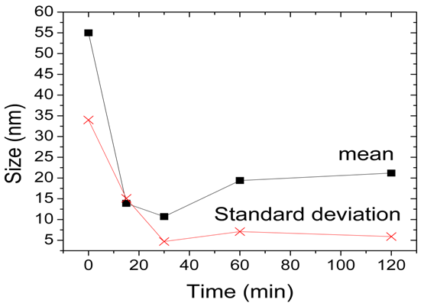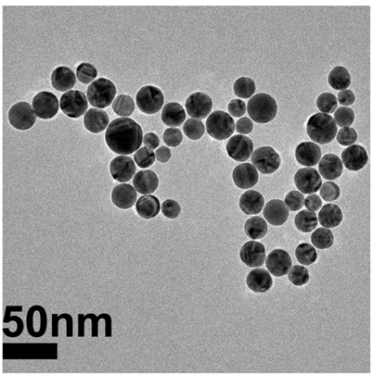
(a) (b)

Figure 1 Captions in 8 point form. (a) The figure, as well as each axis coordinates and titles must be large enough to be easily read. (b) Any micrographs being used should have very good contrast in order to ensure proper visibility.

All references should numbered and appear at the end of the abstract in the same order as used in the text. The font should be the same as the main body of the text but with an 8 pt size. Reference should be aligned to the left. In the main body of the text, the reference designation should be with square brackets [1], and several references can be included together using a comma [2, 3]. If three or more consecutive references occur together, a dash is to be used [1-3]. The abstract must be submitted in a Microsoft Word format.

[1] A. Author¹ and A. Author², Title of paper, Journal Name, vol., pp. startpage-endpage, (year).
[2] A. Author¹, B. Author², C. Author³, Title of paper, Journal Name, vol., pp. start-end, (year).
[3] A. Author¹, Title of book (Publisher), Chapter, (year).

